**Instruction for Adding a Consent Form Page into a oTree Project**

**Written by: Ziqiao Ao**

**STEP 1: Create a IntegerField variable “Yes_No” for the consent form, which has two values:**

**1 —— Yes. I have read and understood the above information, I choose to participate. 0 —— No. I don't want to participate.**

Go to , click , edit as following:

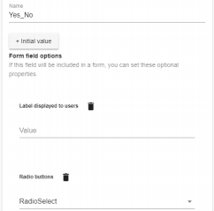

1

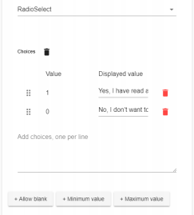

**STEP 2: Add a consent form page and include the "Yes_No" variable into the consent form page.**

Go to Pages and click “+Page”.

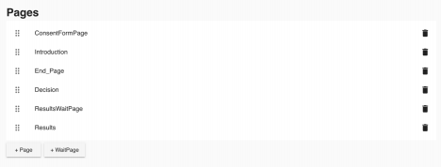Change the page name to “Consent Form” and click “+form_fields” to add the "Yes_No" variable.

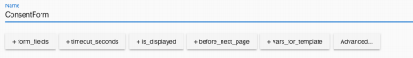Click “Yes_No” to add.

2

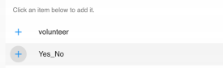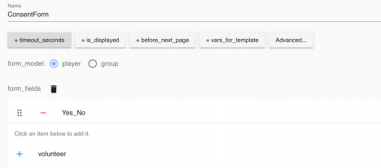

**STEP 3: Create an “End_Page” which would show up if the subject choose “No” in the Consent Form Page, then the experiment will be ended.**

The code is below. (In the "End_Page")

Add “+is_displayed” into the End_page.

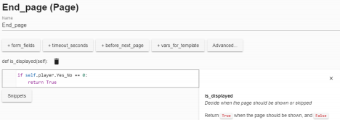3

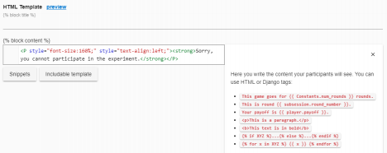

**STEP 4: If the subject choose "Yes", then the experiment will continue and show the introduction page.**

Add “+is_displayed” into the intro page.

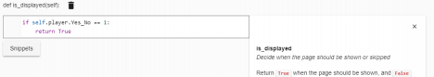

**STEP 5: Code in the Consent Form Page:**

See the coding attachment of the consent form code, you could change the content according to your specific experiment.

4